**Use case Diagram**

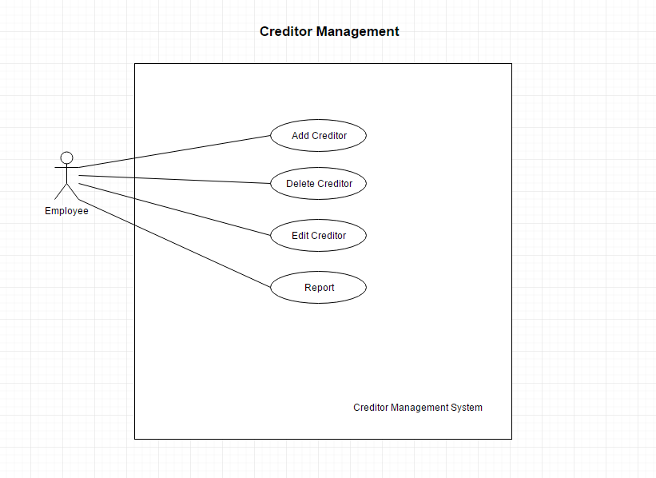

**Class Diagram**

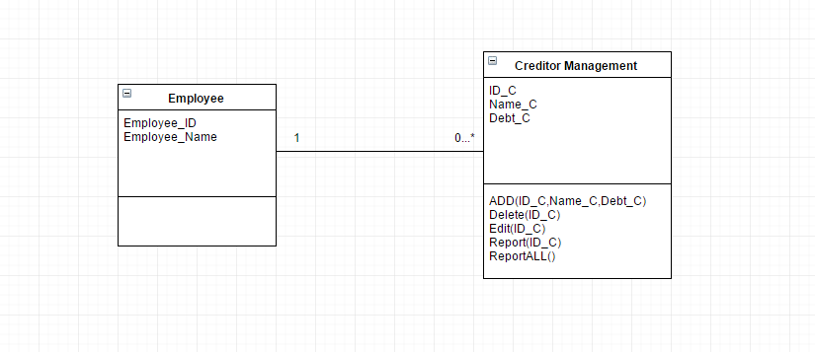

**Sequence Diagram demonstrating operation “Add Creditor”**

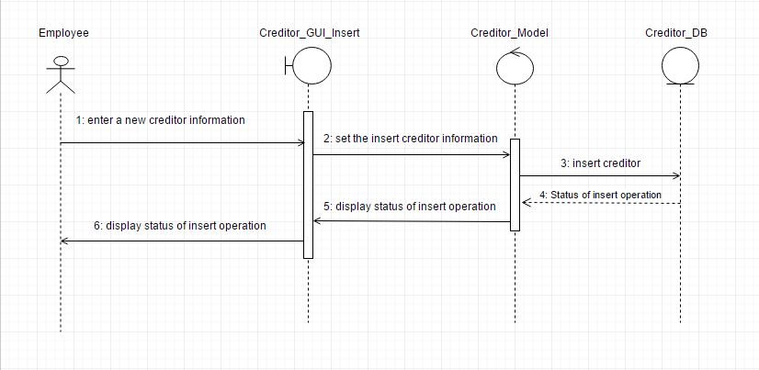

**Sequence Diagram demonstrating operation “Delete Creditor”**

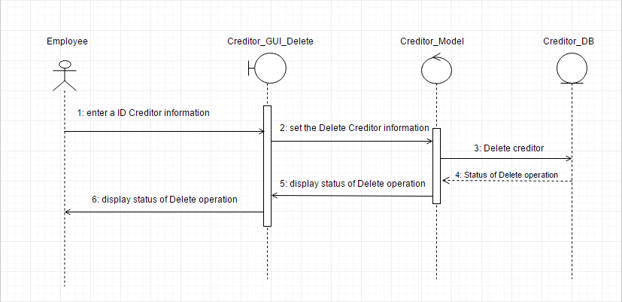

**Sequence Diagram demonstrating operation “Edit Creditor”**

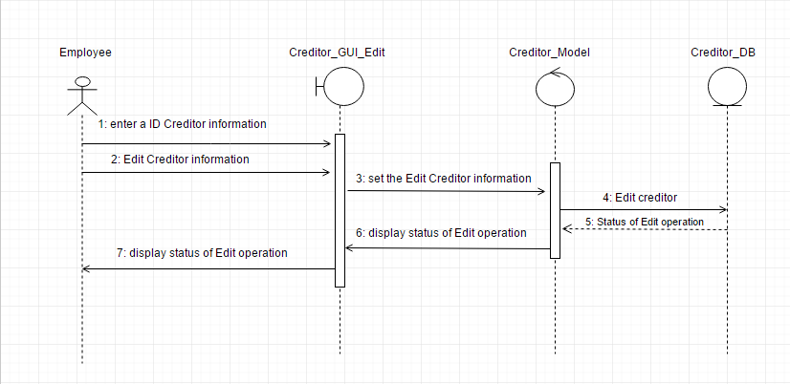

**Sequence Diagram demonstrating operation “Report Creditor”**

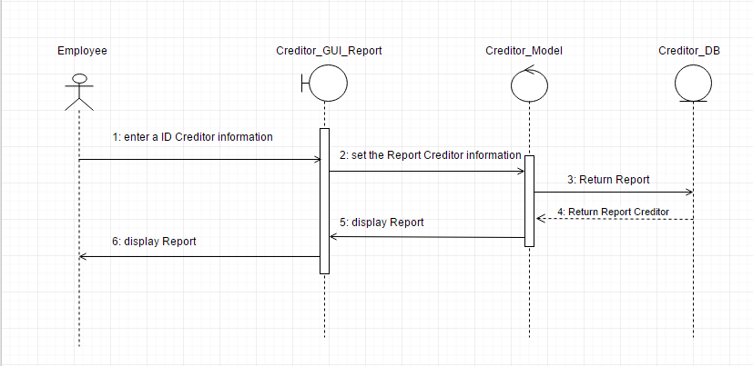

**Sequence Diagram demonstrating operation “ReportAll Creditor”**

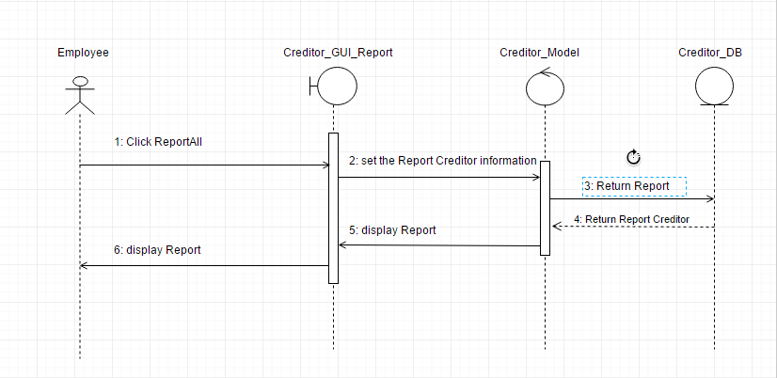

**Model-View-Controller (MVC) Model “Add Creditor”**

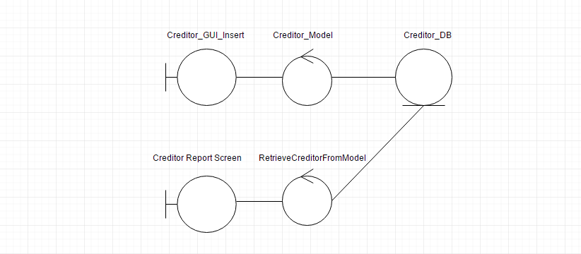

**Model-View-Controller (MVC) Model “Delete Creditor”**

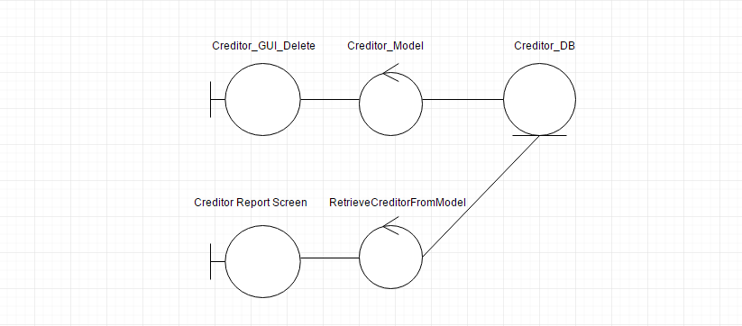

**Model-View-Controller (MVC) Model “Edit Creditor”**

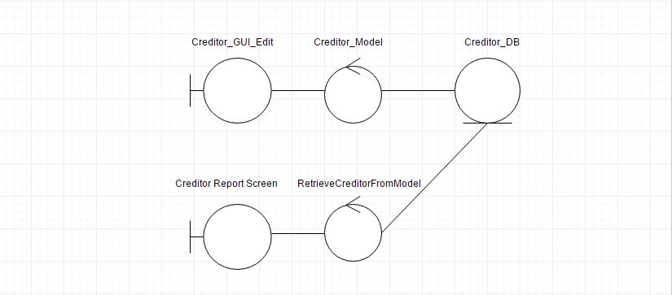

**Model-View-Controller (MVC) Model “Report Creditor”**

